

**COWLAR Task Report**

**Name**:

Talha Tahir Khurshid

**Applicant:**

AI/ML Job

**Status:**

* Completed Videos:

1. Git & Github CrashCourse
2. Resolving Git Merge conflicts
3. Advanced Git
4. Python with OOP
5. The Complete Guide to Python Virtual Environments!
6. Specialization in deep learning part-1
7. Specialization in deep learning part-2
8. Specialization in deep learning part-3
9. Specialization in deep learning part-4

* Task 1: Almost completed (98%)
* Task 2: Not started

**Problems:**

* **Creating a dataset:** Since I read the dataset in order, it was not giving accurate results in the algorithm so I manually reshuffled the entire dataset to get a randomized training and testing data set.
* **Reading a CSV file correctly:** Had problems accessing the first row of the dataset, as it was taken as an index, so I tried adding a new row but then finally the problem was solved by setting header = NONE when reading the CSV file.
* **Problem in measuring distances using KNN:** Had a problem in implementing the Euclidean distance, but later realized after checking the entire KNN algorithm that I had missed a negative sign in the formula.

**Results:**

* The results shown below implement KNN using 5 and 8 classes.

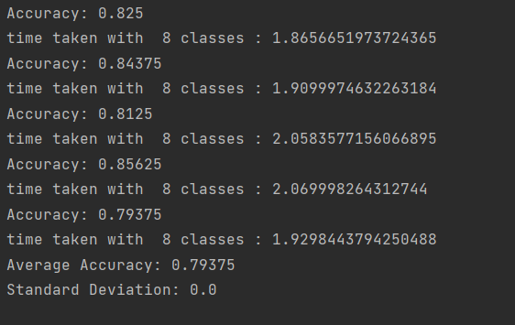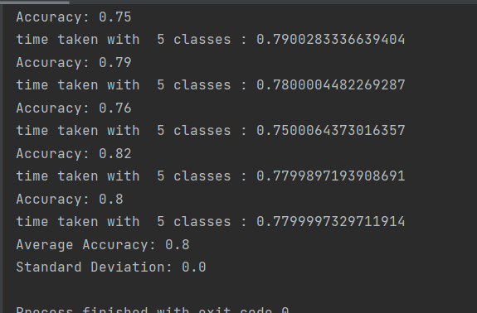

* 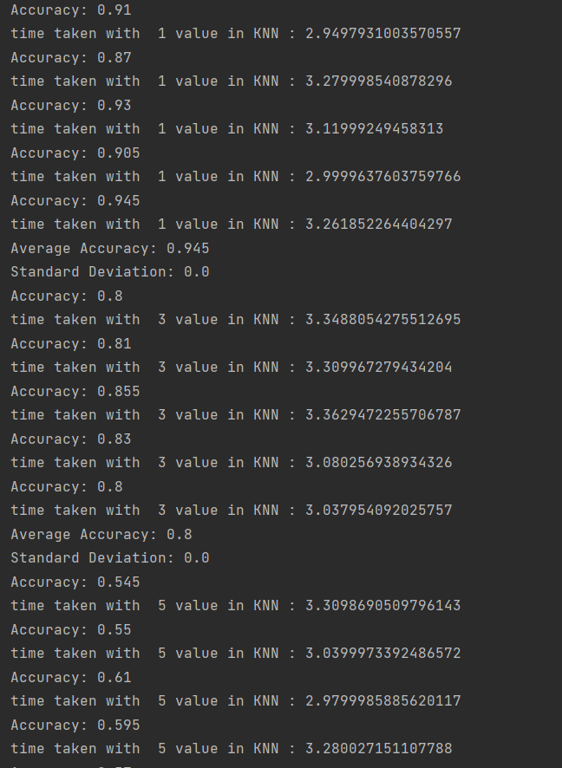The below shows the result of using different values of ‘K’ in KNN.

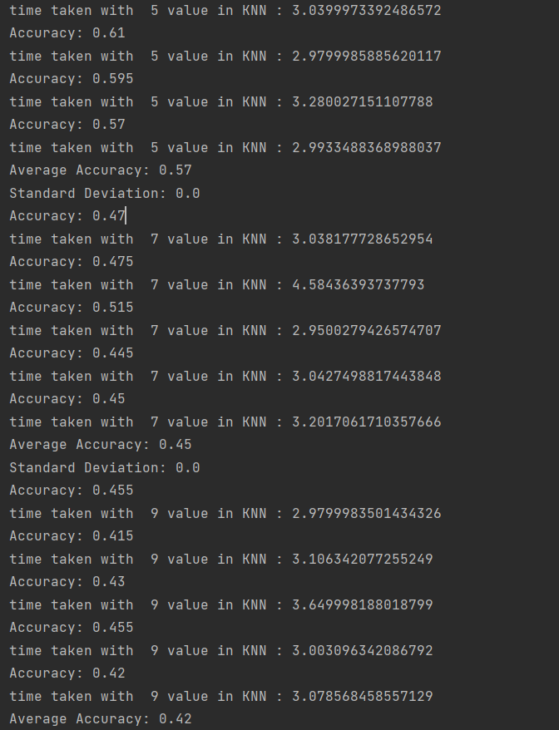

* 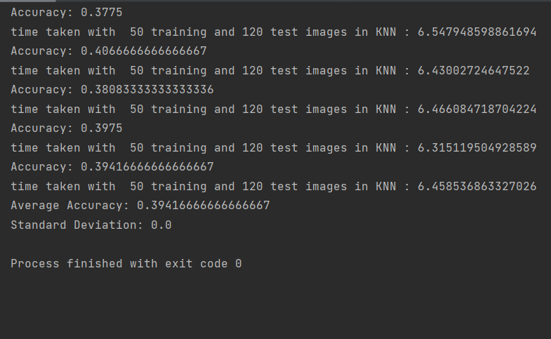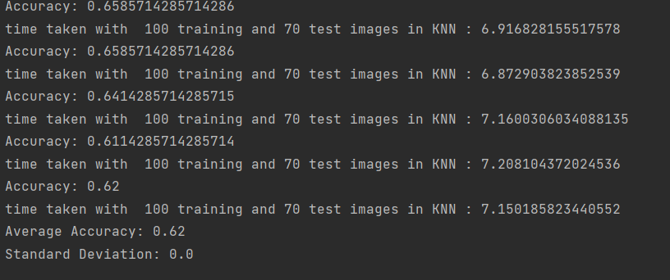The below results show the effect less training images in the KNN classify.
* These results show the effect using the dimension reduction technique using principle component analysis (PCA). The PCA is set to 50.

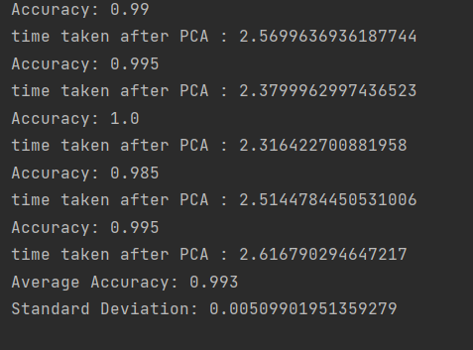The time is reduced roughly by 0.5 seconds.

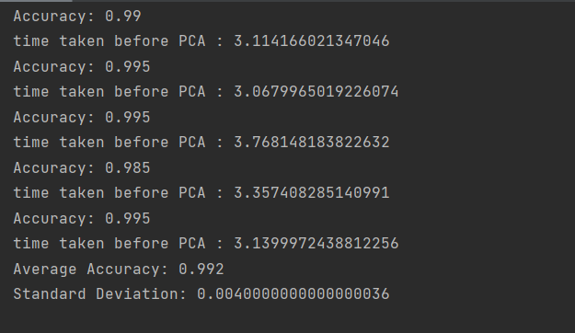

* 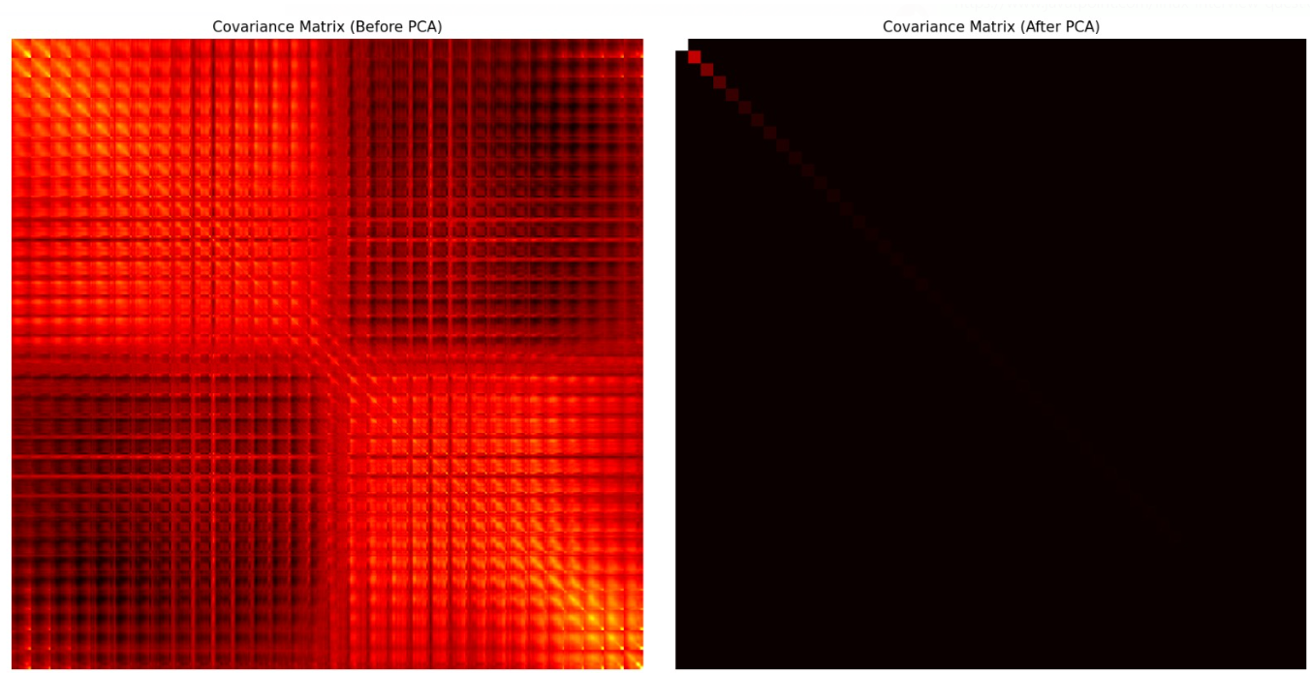Covariance matrix visualization: